TEAM 17：

Uber – the Success of Shared Economy

**Introduction:**

America has been long blamed for its terrible public transportation, but there is one exception - New York. You can totally reliable on subway, buses and taxi rather than on your own car. With the rapid development of share economy, Uber has also become a popular choice. Having given tons of data about NYC Uber trip, we are able to analyze the demographics feature of Uber user, and Meanwhile, some prediction can also been made about the

Here are the questions we want to solve:

1. What is the demographics feature of Uber user?
2. Which’s the busiest area in NYC? How many people in total use Uber in that area in 2015?
3. Using linear regression, we try to predict customer behavior and predict the number of potential user in each area?

Guess what? We do find something interesting.

Demographics Feature:

As the society is aging, we can see that the old people in NYC take a large proportion in total population. The trend shows the great need to develop Uber

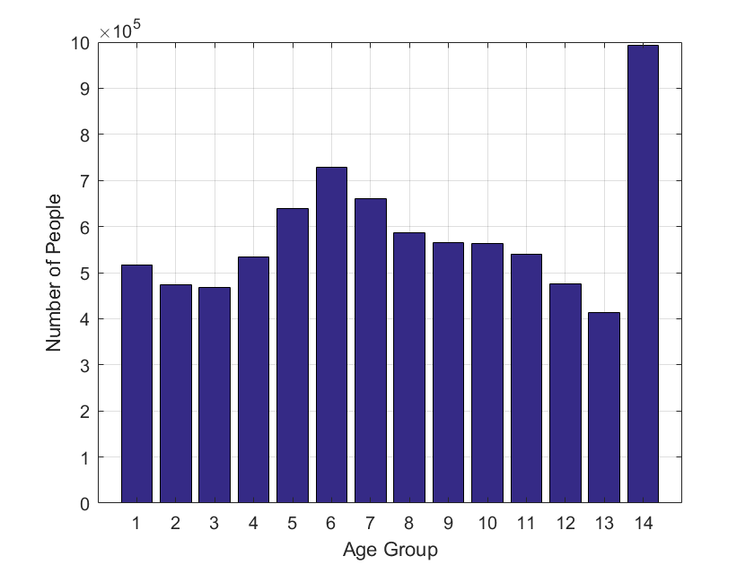

Busiest Area

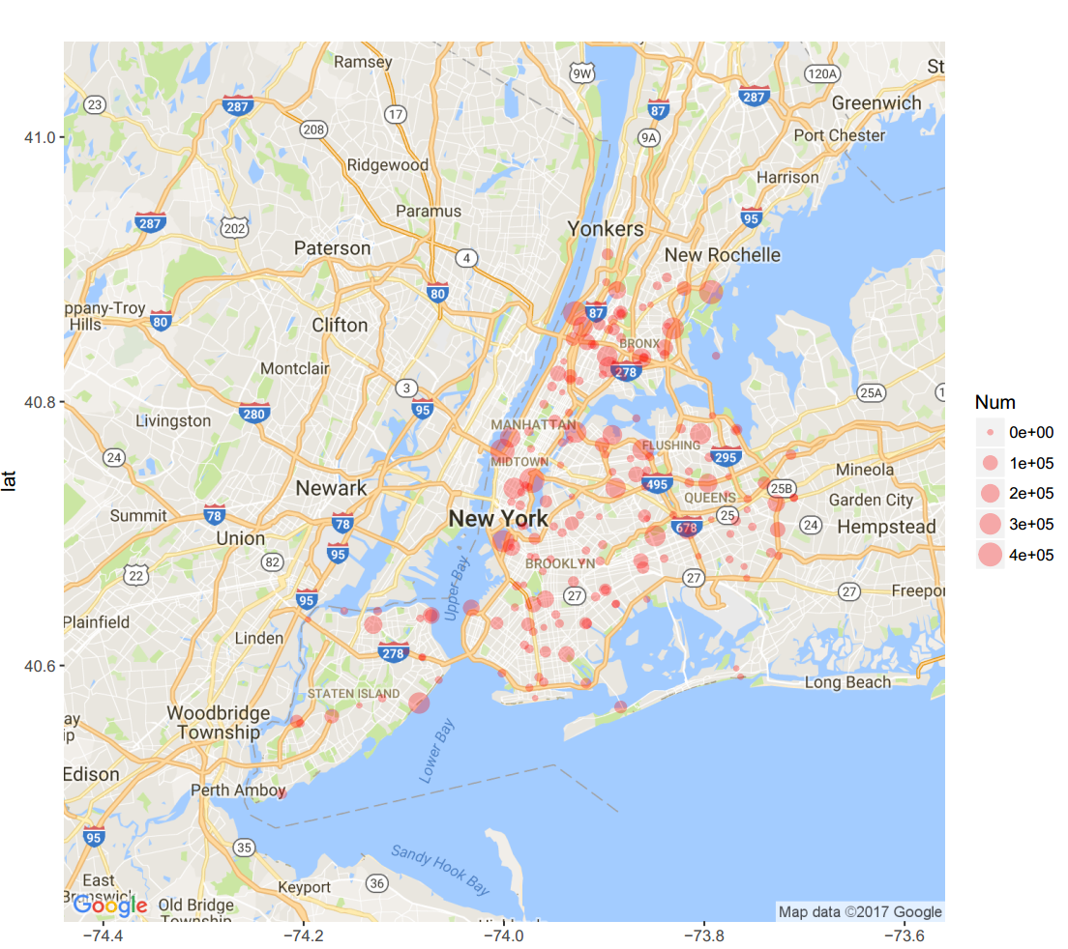Where is the busiest area in NYC? In other words, where can Uber driver pick up more potential rider? Using Uber trip count 2015 dataset, we have the answer. By sorting pickup station with zone ID, we visualize it by scatter plot, with the size of point indicating the total number of rider. As we can see, places near Center Park are the busiest area in NYC. Outside of Manhattan, Brooklyn, Flushing and Queens also have a buddle of Uber users.

The table below give the top 10 busiest taxi zone with their approximate longitude and latitude.

**Table 1. Top Busiest Zone in NYC**

|  |  |  |  |  |  |  |  |
| --- | --- | --- | --- | --- | --- | --- | --- |
| ID | | User counts | | longitude | | latitude | |
| MN20 | 460732 | | -73.97220 | | 40.74041 | |
| MN35 | | 420356 | | -73.92873 | | 40.86675 | |
| MN13 | | 419045 | | -74.00153 | | 40.76265 | |
| BX03 | | 407591 | | -73.79323 | | 40.88283 | |
| MN25 | | 323989 | | -74.00078 | | 40.69429 | |
| BX37 | | 315919 | | -73.83129 | | 40.85544 | |
| QN27 | | 299781 | | -73.86110 | | 40.76367 | |
| SI45 | | 296734 | | -74.08469 | | 40.57149 | |
| QN71 | | 290550 | | -73.92828 | | 40.77691 | |
| QN51 | | 285518 | | -73.80379 | | 40.77562 | |